

**UNIVERSITY OF GREENWICH**  
COMP1649 – Human Computer Interaction Design

Coursework

|  |  |
| --- | --- |
| Student name | Nguyen Nhat Khang |
| ID number (00xxxxxxx) | 001353323 |
| Lecturer/Tutor name | Tran Thi Kim Khanh |
| Student submission date | November 24, 2023 |

Table of Contents

**1.** **Introduction** 6

**2.** **Background literature** 6

**2.1** **HCI Research** 6

**2.2** **HCI Theory** 8

**2.2.1** **Cognitive Psychology** 8

**2.2.2** **Interaction Design Theory** 9

**2.2.3** **Modes of Interaction** 10

**2.2.4** **Types of Interaction** 10

**2.2.5** **Design Principles** 11

**2.2.6** **Design Pattern** 12

**3.** **Design Process** 12

**3.1** **Conceptual Design** 12

**3.1.1** **User Requirements** 12

**3.1.2** **Problems and Solutions** 12

**3.1.3** **Hierarchical Model** 12

**3.1.4** **Conceptual Model** 13

**3.2** **Design principles** 20

**4.** **Prototype** 22

**4.1** **Physical Prototype** 22

**4.2** **Low-fidelity Prototype** 23

**4.3** **Mid-fidelity Prototype** 23

❖ **Loading** 23

❖ **Sign in** 24

❖ **Sign up** 24

❖ **Store** 25

❖ **Dive log** 25

❖ **Add new dive** 26

❖ **Detail and edit dive** 27

❖ **Tracking** 28

❖ **Take photo** 29

❖ **Record video** 29

❖ **Save tracking information** 30

❖ **Scuba diving** 31

❖ **Settings** 31

**5.** **Research Study** 32

**6.** **Conclusion** 39

References 40

Appendices 41

Table of Figures

Figure 1 Dive Board [diveboard, 2023] 6

Figure 2 Diving Log interface [Knoch, 2023] 7

Figure 3 iDive [GÁBOR, 2021] 7

Figure 4 i770R Dive Computer interface [aqualung, 2023] 7

Figure 5 Descent™ Mk2i [garmin, 2023] 8

Figure 6 Hierarchical Model 13

Figure 7 Conceptual Model 14

Figure 8 Front of physical prototype 22

Figure 9 Back of physical Prototype 23

Figure 10 Low-fidelity of the Login, Dive log, Tracking screen 23

Figure 11 Main screen of phone (1) and loading screen (2) 24

Figure 12 Login screen 24

Figure 13 Sign up screen 25

Figure 14 Dive store screen 25

Figure 15 Dive log screen 26

Figure 16 Select diving mode screen (1), Add new dive screen (2,3), Dive log screen (4) 26

Figure 17 Add another dive mode 27

Figure 18 Dive detail screen (2) and edit dive screen (3) 27

Figure 19 Tracking without air tank screen 28

Figure 20 Turn on flashlight 28

Figure 21 Start tracking 28

Figure 22 Camera screen 29

Figure 23 Take a photo screen 29

Figure 24 Video screen 29

Figure 25 Record video screen 30

Figure 26 Save information of tracking 30

Figure 27 View dive detail after diving screen (1,2) and view expand dive photo screen (3,4) 30

Figure 28 Tracking with air tank screen 31

Figure 31 Profile screen 31

Figure 32 Setting screen (1), Help center screen (2) and Term & polices screen (3) 32

Figure 33: Result of question 1 33

Figure 34 Result of question 2 33

Figure 35 Result of question 3 34

Figure 36 Result of question 4 34

Figure 37 Result of question 5 34

Figure 38 Result of question 6 35

Figure 39 Result of question 7 35

Figure 40 Result of question 8 36

Figure 41 Result of question 9 36

Figure 42 Result of question 10 37

Table of Tables

Table 1 Metaphors table 15

Table 2 Design principles table 20

Table 3 Nielsen usability heuristics 37

1. **Introduction**

I designed this scuba diving app to meet user needs because current applications lack dive tracking. It records adventures, offers diving conditions and locations, monitors depth and temperature, and enhances each dive experience. The report covers seven sections: a literature review for project insights, HCI concepts applied, conceptual design with visualizations, design principles' integration, low- and mid-fidelity prototypes, a proposal for empirical research using the prototype, and critical reflections on the completed work.

1. **Background literature**
   1. **HCI Research**

Researching successful apps in similar domains is vital for new app development. During my project's preparation, I extensively studied these apps to understand their features, interfaces, and implementations. This exploration revealed impressive applications, each with unique strengths and user experiences. Below, I share the apps I researched, drawing valuable insights for my own app development.

**Dive Board**

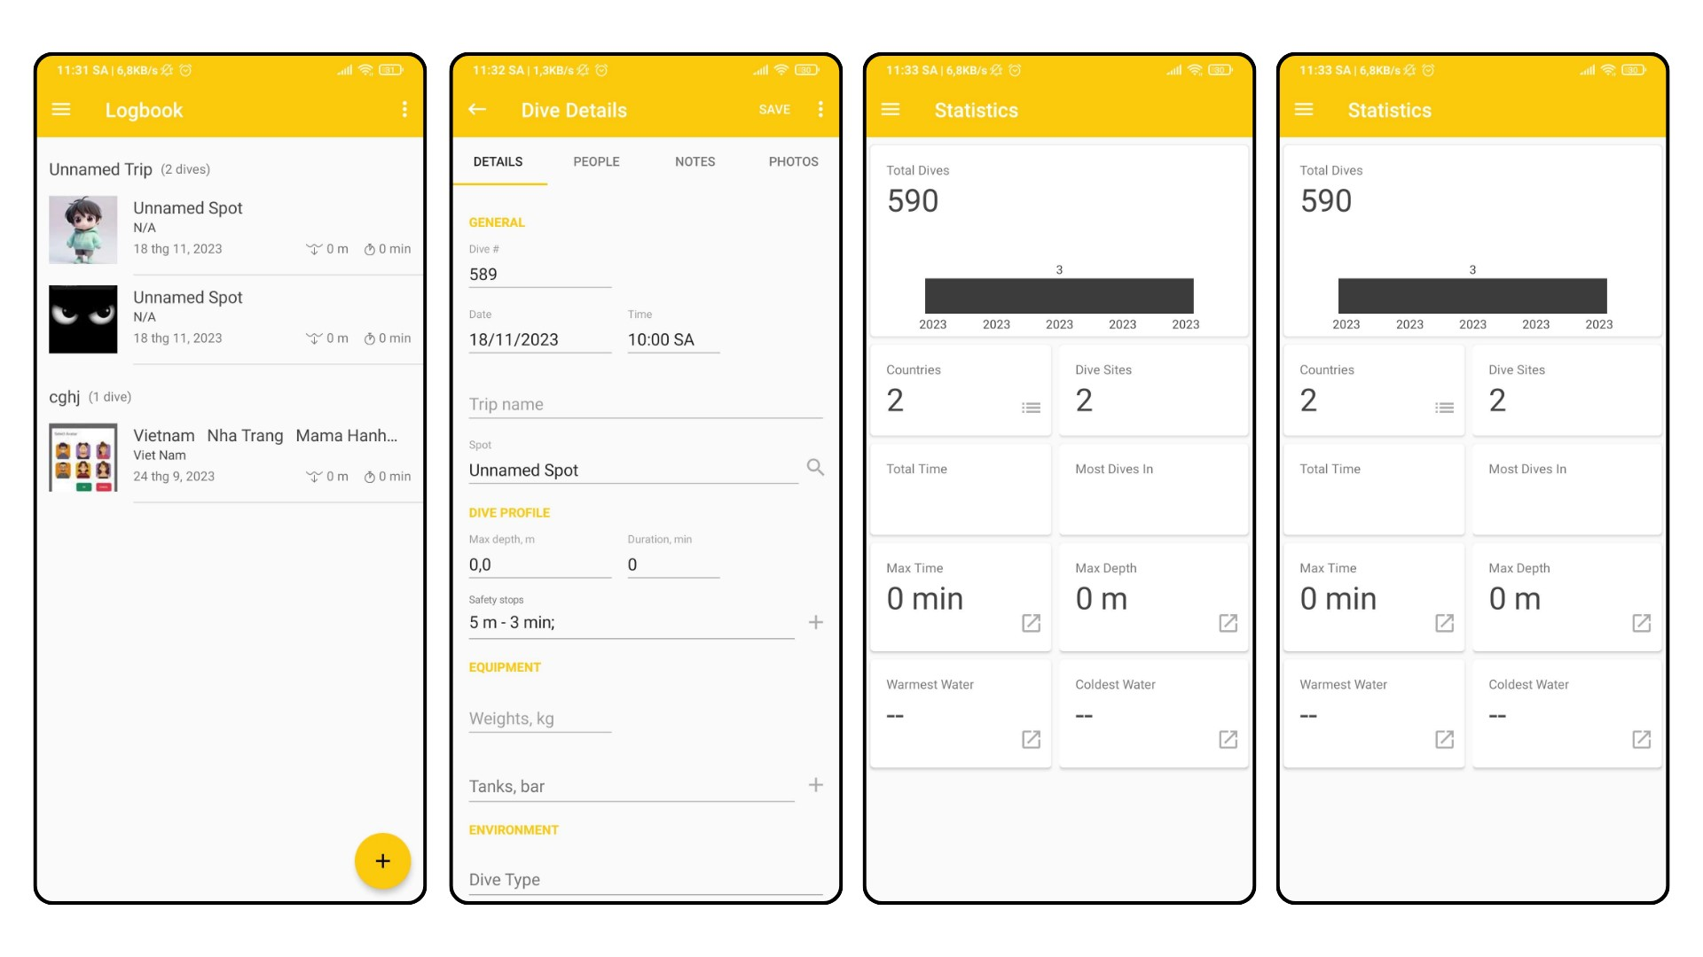

Figure 1 Dive Board [diveboard, 2023]

**Diving Log**

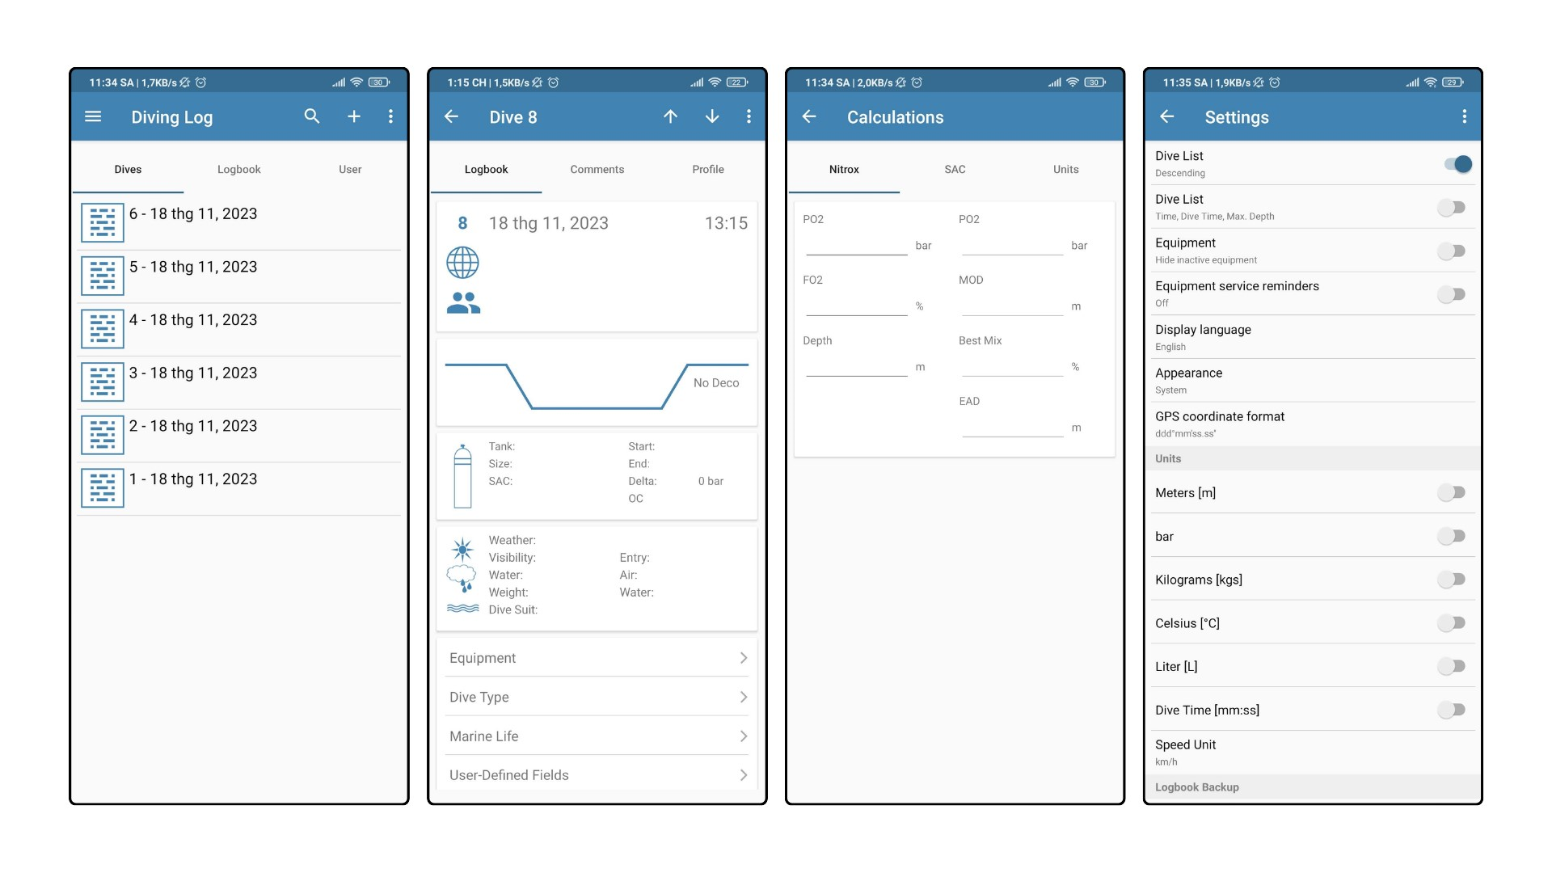

Figure 2 Diving Log interface [Knoch, 2023]

**iDive**

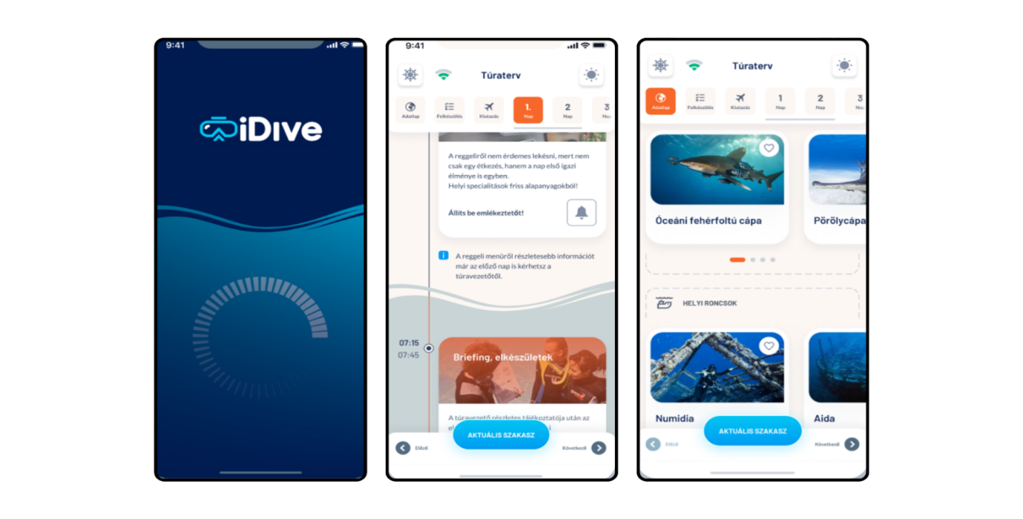

Figure 3 iDive [GÁBOR, 2021]

**i770R Dive Computer**

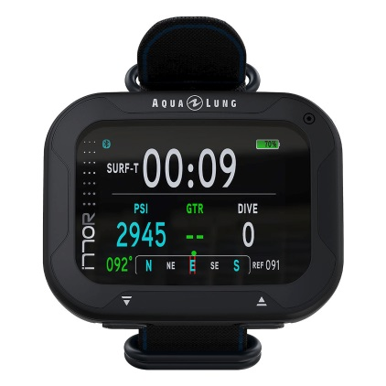

Figure 4 i770R Dive Computer interface [aqualung, 2023]

**Descent™ Mk2i**

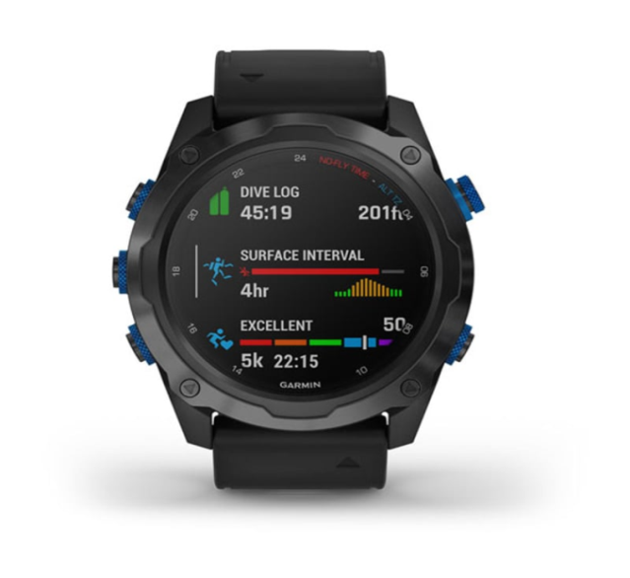

Figure 5 Descent™ Mk2i [garmin, 2023]

I learned and applied these improvements to my application interface

* **Optimize Information Structure and Display:** easily accessible information display. I've organized elements and features logically for efficient user access without clutter or delays.
* **Create a Friendly and Engaging Experience:** Employ fitting colors and images to emphasize key details and craft an engaging interface. My aim was to make an interface both visually appealing and user-attractive.
  1. **HCI Theory**

HCI is a diverse field that studies how humans and computers interact. It involves designing and implementing interactive systems to enhance user experience and improve the usability, accessibility, and effectiveness of technology [Rogers, Preece and Sharp, 2015].

* + 1. **Cognitive Psychology**

Cognitive psychology delves into mental processes like perception, memory, problem-solving, and language use. Through experiments, psychologists study how individuals gather, process, and use information, aiming to understand its impact on behavior

* **Memory:** Studying how the human mind processes, stores, and recalls information, including different memory types like short-term, long-term, and working memory. In my app, clear and easy-to-find information, reminding users of vital details like depth, temperature, and remaining oxygen levels in the tank.
* **Attention:** Studying how individuals concentrate on specific information while disregarding irrelevant stimuli, and examining the constraints and workings of attention. So my app will adjust the way it displays information. For example, icons will be more prominent than other information to attract user attention.
* **Language Processing:** Investigating language acquisition, processing, and comprehension includes analyzing syntax, semantics, and pragmatics. In my app, utilizing common words helps users comprehend without the need to search or misunderstand their meaning.
* **Learning:** Understanding user interaction with new interfaces involves creating intuitive designs for easier learning, reducing the necessity for extensive training. My app will feature a user-friendly interface, utilizing icons instead of text to facilitate easy navigation, particularly for new users.
* **Thinking:** Higher cognitive functions encompass logical reasoning, creative thinking, and manipulating mental representations. In my app, I've developed a radar system to indicate the location of moving objects underwater, aiding users in accessing information and navigating challenging underwater environments with limited visibility in a logical and intuitive manner.
* **Problem-Solving and Decision-Making:** Studying mental processes includes understanding heuristics, biases, and strategies. My app notifies users of errors, such as when required fields are blank, enabling them to resolve issues without external guidance.
* **Perception:** Researching how people interpret sensory information involves visual, auditory perception, and integrating sensory inputs. In my app, interface elements will have clear designs, using suitable colors to highlight vital information.

[Rogers, 2019]

* + 1. **Interaction Design Theory**

A conceptual model is a simplified framework that explains the basic principles, structure, and connections among components in an interactive system. It provides an abstract view of how users understand and engage with the system [Jeff Johnson, 2011].

In HCI, a prototype is an initial model or version of a product or system created to test design ideas, functionalities, and interactions before finalizing the product. Prototypes help in gathering feedback, spotting design issues, and improving the overall user experience before the final development stage.

There are several types of prototypes commonly used in HCI:

* **Low-Fidelity:**
* Paper Prototypes: Quick sketches for early testing.
* Wireframes: Basic layouts focusing on structure.
* Mockups: More detailed visuals without full interactivity.
* **Mid-Fidelity:**
* Clickable Prototypes: Interactive simulations using tools.
* HTML/CSS Prototypes: Web-based, interactive models.
* **High-Fidelity:**
* Interactive Prototypes: Detailed, closely resembling the final product.
* Simulations: Focused on specific functionalities or scenarios.

In my design I can apply Low Fidelity and Medium Fidelity, I will show and explain them in the prototype section.

[Rogers, Preece and Sharp, 2015]

* + 1. **Modes of Interaction**

Interaction modes encompass the diverse methods users utilize to interact with a computer system or interface, facilitating task completion or communication. These modes define the interaction nature between humans and computers

* **Graphical User Interface (GUI):** This mode involves interactions through visual elements like windows, icons, buttons, and menus. Users interact by clicking, dragging, typing, or using gestures on the screen. GUIs are prevalent in operating systems, applications, and websites.
* **Touch-based Interaction:** becoming standard in smartphones, tablets, and other devices due to the widespread use of touchscreens. By using touch movements like pinching, swiping, and tapping, users can interact with the system.
* **Command-Line Interface (CLI):** In a CLI, users interact with the system by typing commands using a text-based interface. This mode requires users to have specificknowledge of commands and syntax but can be powerful and efficient for experienced users.
* **Voice User Interface (VUI):** VUI enables interaction through voice commands and responses. Virtual assistants like Siri, Alexa, or Google Assistant use VUI, allowing users to perform tasks, ask questions, or control devices using speech.

My application will use touch-based interaction.

[Rogers, 2019]

* + 1. **Types of Interaction**

The choice of interaction type depends on various factors, including the context, audience, goals, and the nature of the interaction

* **Instructing:** This type offers clear, direct guidance, ideal for conveying information, teaching skills, or giving step-by-step instructions. My app simplifies creating a dive log, including details like log name, dive location, and date.
* **Conversing:** Conversing involves engaging in dialogue or conversation. It's useful for fostering communication, exchanging ideas, discussing topics, or building relationships. It's more interactive and allows for a two-way exchange of information.
* **Manipulating:** Manipulating interactions controls elements in a system, whether physically or through data. My app lets users manage their dive log by editing, adding, or removing information.
* **Exploring:** This promotes independent exploration commonly seen in user interfaces or environments, allowing freedom to explore content or features at your own pace. My app enables users to delve into tracking features, access tracking data, and gain a deeper grasp of their underwater journey information.
* **Responding:** Responding interactions entail reacting to user input or stimuli, such as acknowledging a command, answering a query, or reacting to a situation. My app will notify users of actions (add, edit, delete) or errors caused by user actions.

[Rogers, 2019]

* + 1. **Design Principles**

In HCI, design principles guide creating user-friendly interfaces and systems, improving usability and user experience by drawing from psychology, ergonomics, and cognitive science.

* **Visibility:** Clarity in the interface helps users find and use app elements naturally. In my application's tracking interface, I'll use larger fonts and high-contrast colors for better visibility in low-light or low-visibility conditions.
* **Feedback:** This principle ensures user understanding by giving feedback after interface actions. My app will show floating notifications for actions like adding, editing, or deleting a dive log.
* **Constraints:** This involves using restrictions to guide users and prevent unwanted actions, making the interface clearer. When the tracking status is active in the app, trying to exit will be blocked with a message indicating that exiting isn't possible during active tracking.
* **Consistency:** Consistency in interface elements ensures a seamless user experience across pages or features. I maintain a similar layout across different interfaces, like making the "NEW DIVE" screen will be similar to the "EDIT DIVE" screen for user familiarity.
* **Affordance:** Interface elements should effectively convey their functions to users. I use familiar icons in my application to ensure clear functionality; for instance, a camera icon instantly signals the photography function to users.
  + 1. **Design Pattern**

In HCI, design HCI design patterns offer proven solutions for common usability and interaction issues in crafting user interfaces or experiences, providing best practices and guidelines to tackle design challenges effectively.

* **Account Registration:** To deliver tailored content or opportunities to make a purchase, you need to know who the current user is. My application provides a registration function to manage user information (ui-patterns, 2023).
* **Settings:** The user requires a central location to specify preferences for the behavior of the program. My app provides a settings screen where the user can toggle wifi and Bluetooth on and off (ui-patterns, 2023).
* **Input Prompt:** Users tend to swiftly complete forms to access services, often skimming through fields. Input prompts in my app immediately focus users on essential information. For login and register features, I use hints instead of labels to simplify interaction.(ui-patterns, 2023).

1. **Design Process**
   1. **Conceptual Design**
      1. **User Requirements**

The Diving app's design tracks dive specifics like depth, ascent time, air, duration, and sea temperature. Users review dive history and capture photos/videos during dives, viewable after returning.

* + 1. **Problems and Solutions**

The app resolves issues by indicating gas levels, aiding time management to prevent oxygen depletion, and other risks of diving. It enables capturing underwater moments and storing detailed dive data, including technical information, images, and videos.

* + 1. **Hierarchical Model**

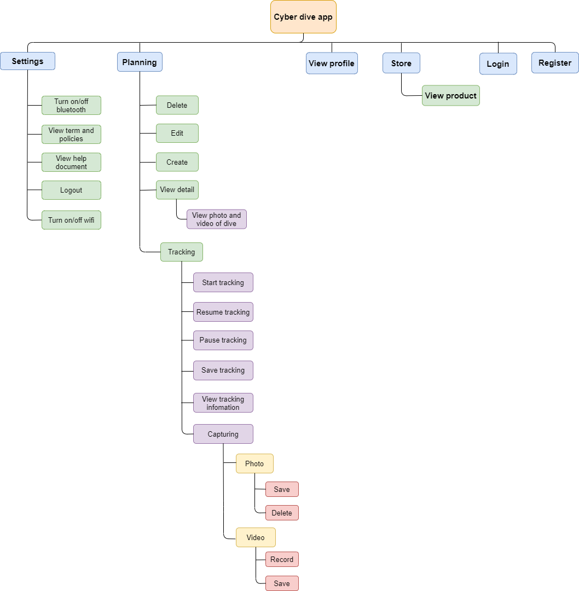

Figure 6 Hierarchical Model

* + 1. **Conceptual Model**

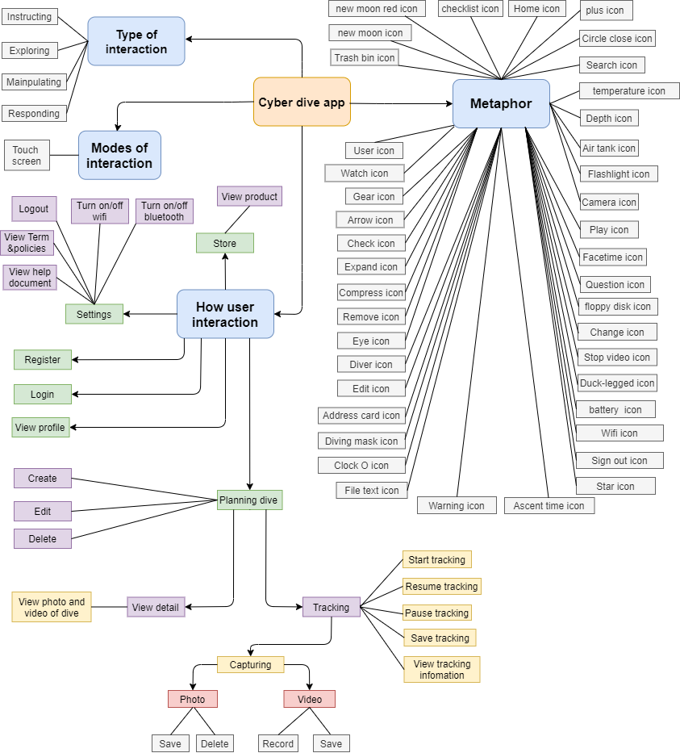

Figure 7 Conceptual Model

**Metaphors**

Table 1 Metaphors table

|  |  |
| --- | --- |
| **Icon** | **Description** |
| **D:\TOPUP\design\dev\image\fins.png** | Duck-legged icon - view diving suits product screen |
| **D:\TOPUP\design\dev\image\oxi.png** | Air tank icon - display amount of oxygen remaining in the tank |
| **D:\TOPUP\design\dev\image\user-profile.png** | User icon – open profile screen |
| **D:\TOPUP\design\dev\image\dive-computer.png** | Watch icon – open watch diving product screen |
|  | Gear icon – open settings screen |
| **D:\TOPUP\design\dev\image\left-arrow.png** | Arrow icon – turn back previous screen |
| **D:\TOPUP\design\dev\image\check.png** | Check icon – Save dive planning information |
| **D:\TOPUP\design\dev\image\expand.png** | Expand icon – expand photo and video list of dive log |
| **D:\TOPUP\design\dev\image\minimize.png** | Compress icon – mini size photo and video list of dive plan |
| **D:\TOPUP\design\dev\image\delete-cross.png** | Remove icon – close take video or photo function |
| **D:\TOPUP\design\dev\image\eye.png** | Eye icon – open dive planning detail |
| **D:\TOPUP\design\dev\image\diving.png** | Diver icon – open tracking screen |
| **D:\TOPUP\design\dev\image\edit.png** | Edit icon – open edit dive planning screen |
| **D:\TOPUP\design\dev\image\address-card.png** | Address card – display username of user |
| **D:\TOPUP\design\dev\image\diving-goggles.png** | Diving mask icon – open diving mask product screen |
| **D:\TOPUP\design\dev\image\three-o-clock-clock.png** | Clock O icon – display diving time |
| **D:\TOPUP\design\dev\image\file.png** | File text icon – open term & policies |
| **D:\TOPUP\design\dev\image\caution.png** | Warning icon – display on top of warning popup |
| **D:\TOPUP\design\dev\image\star.png** | Star icon – rating of product in store |
| **D:\TOPUP\design\dev\image\sign-out-option.png** | Sign out icon – log out of application |
| https://cdn.discordapp.com/attachments/1156498062877921360/1175759725183373342/tide.png?ex=656c6693&is=6559f193&hm=8b2a4abbc76bd1e18facf05b76c351222400724ae93854ef0fdbaacc27936995& | Ascent time icon – shows the time taken to reach the surface |
| **D:\TOPUP\design\dev\image\wifi.png** | White wifi icon – shows wifi connection |
| **D:\TOPUP\design\dev\image\rss.png** | Gray wifi icon – turn on/off wifi |
| **D:\TOPUP\design\dev\image\battery.png** | battery  icon – displays the phone's battery level |
| **D:\TOPUP\design\dev\image\stop-button.png** | Stop video icon – stop and save record video |
| **D:\TOPUP\design\dev\image\change.png** | Change icon – toggle between camera and record video function |
| **D:\TOPUP\design\dev\image\floppy-disk.png** | Floppy disk icon – save a tracking information |
| **D:\TOPUP\design\dev\image\new-moon.png** | New moon icon – take a photo |
| **D:\TOPUP\design\dev\image\new-moon red.png** | New moon red icon – start record video |
| **D:\TOPUP\design\dev\image\play.png** | Play icon – start tracking function |
| **D:\TOPUP\design\dev\image\camera.png** | Camera icon – open camera screen |
| **D:\TOPUP\design\dev\image\facetime-button.png** | Facetime icon – open record video screen |
| **D:\TOPUP\design\dev\image\question.png** | Question icon – open help center |
| https://cdn.discordapp.com/attachments/1156498062877921360/1175758106903466044/flashlight_1.png?ex=656c6511&is=6559f011&hm=fc958f3ec1daeeff1bfcded919388cccd6caf858c40c2c0bb314f52c7a6822b6& | Flashlight icon – turn on/off flashlight of phone |
| https://cdn.discordapp.com/attachments/1156498062877921360/1175745983498424361/pool-depth.png?ex=656c59c6&is=6559e4c6&hm=4d2c9159dbc22542df86ae5cbab8365decc69f99c5e4cb1c02c4f8ead2e0fb15& | Depth icon – Displays current depth when tracking |
| https://cdn.discordapp.com/attachments/1156498062877921360/1175759934437199922/temperature.png?ex=656c66c4&is=6559f1c4&hm=1d11dae4d09049aacbeeb8d01b443b39671224d313d8bca338d6203f6220a3e3& | temperature icon – Displays sea water temperature when tracking |
| **D:\TOPUP\design\dev\image\search.png** | Search icon – let users know this is a search field |
| https://cdn.discordapp.com/attachments/1156498062877921360/1175760792977690655/delete.png?ex=656c6791&is=6559f291&hm=9d4d834a28c05647e145e6173024748087ed432a3a6b43072c6a49448d692138& | Circle close icon – Delete all character in search field |
| **D:\TOPUP\design\dev\image\plus.png** | Plus icon – open add new dive screen |
| **D:\TOPUP\design\dev\image\home.png** | Home icon – open home screen |
| **D:\TOPUP\design\dev\image\checklist.png** | Checklist icon – open dive log list |
| **D:\TOPUP\design\dev\image\trash-bin.png** | Trash bin icon – remove a dive planning |

* 1. **Design principles**

Table 2 Design principles table

|  |  |  |
| --- | --- | --- |
| **Design principles** | **My design** | **Description** |
| Visibility |  | My application's tracking interface, I'll use larger fonts and high-contrast colors for better visibility in low-light or low-visibility conditions. |
| Feedback |  | My app will show floating notifications for actions like adding, editing, or deleting a dive log. |
| Predictability |  | If users attempt to track a dive log already logged, the system warns of potential data overwrite. |
| Learnability |  | Creating a dive log in my app is straightforward: two screens; the first selects dive mode, and the second enters three details. |
| Constraints |  | When the tracking status is active in the app, trying to exit will be blocked with a message indicating that exiting isn't possible during active tracking. |
| Consistency |  | I maintain a similar layout across different interfaces, like making the "NEW DIVE" screen will be similar to the "EDIT DIVE" screen for user familiarity. |
| Affordance |  | I use familiar icons in my application to ensure clear functionality; for instance, a camera icon instantly signals the photography function to users. |

1. **Prototype**
   1. **Physical Prototype**

Below is the front of my waterproof case. It has notable features, for example:

* **"Thumb grip":** users can put their thumb on it to get a more secure grip.
* **"Waterproof case lock":** this is the lock of the case.
* **"Functional buttons":** these are buttons so users can operate the screen without touching the screen; they display icons below their respective functions, including some functions such as opening a flashlight, camera, video, and start and save tracking.

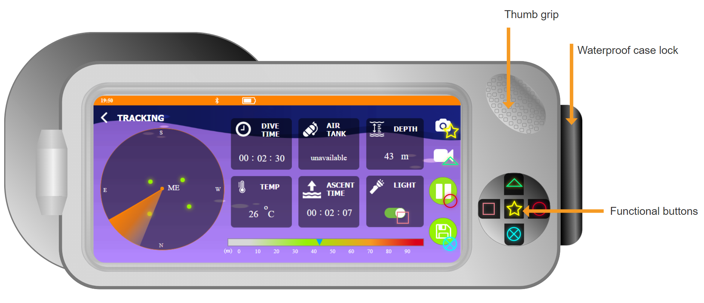

Figure 8 Front of physical prototype

Below is the back of my waterproof case, it's 2 design structures to note are:

* **"Rubber grip":** users can grasp this or combine it with the "thumb grip" to get a firm grip.
* **"Mineral glass lenses":** this is a type of hybrid glass lens that is half the weight of normal glass. They are also stronger, more resistant to scratches and distortions, and can provide greater clarity of vision.

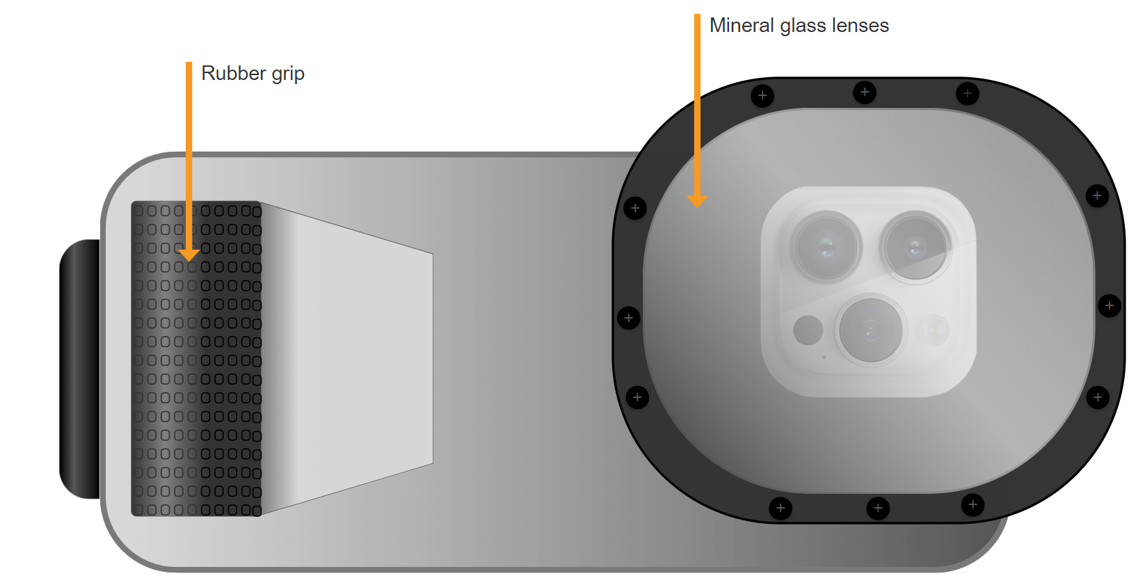

Figure 9 Back of physical Prototype

* 1. **Low-fidelity Prototype**

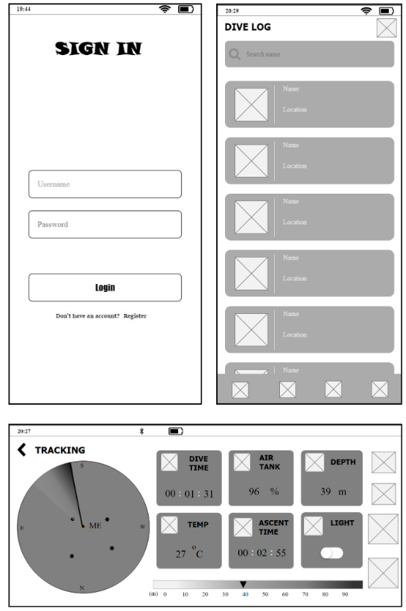

Figure 10 Low-fidelity of the Login, Dive log, Tracking screen

* 1. **Mid-fidelity Prototype**
* **Loading**

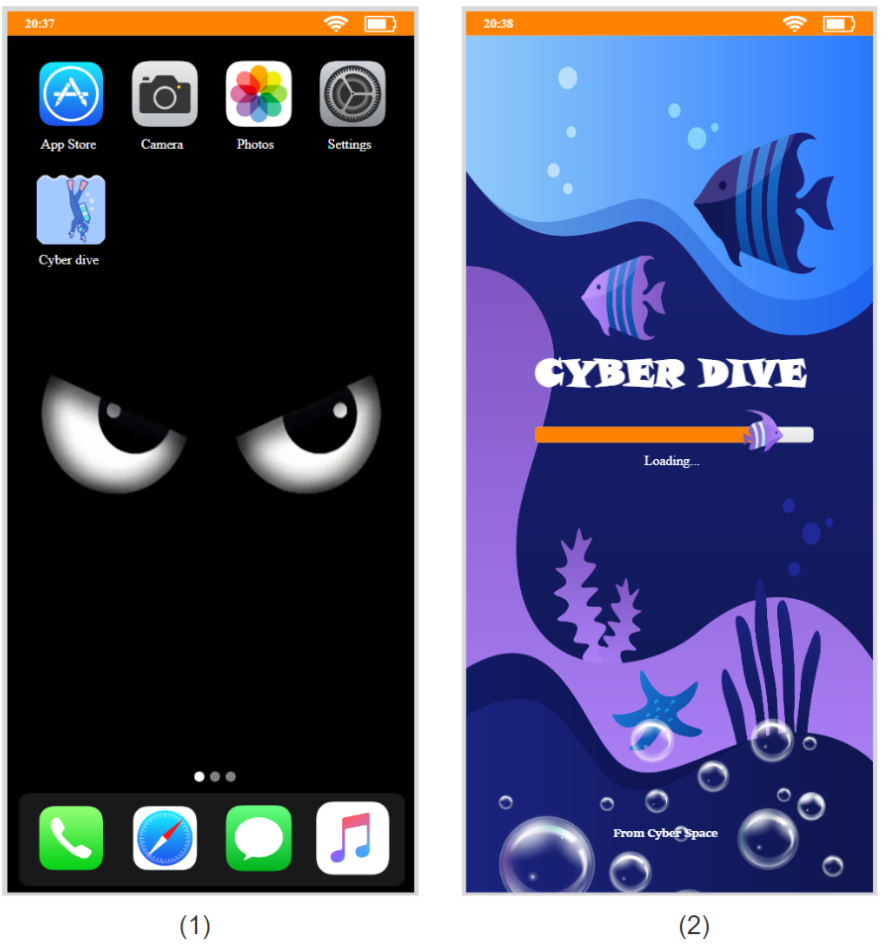

Figure 11 Main screen of phone (1) and loading screen (2)

This is the application icon and loading screen when the user has just opened the application.

* **Sign in**

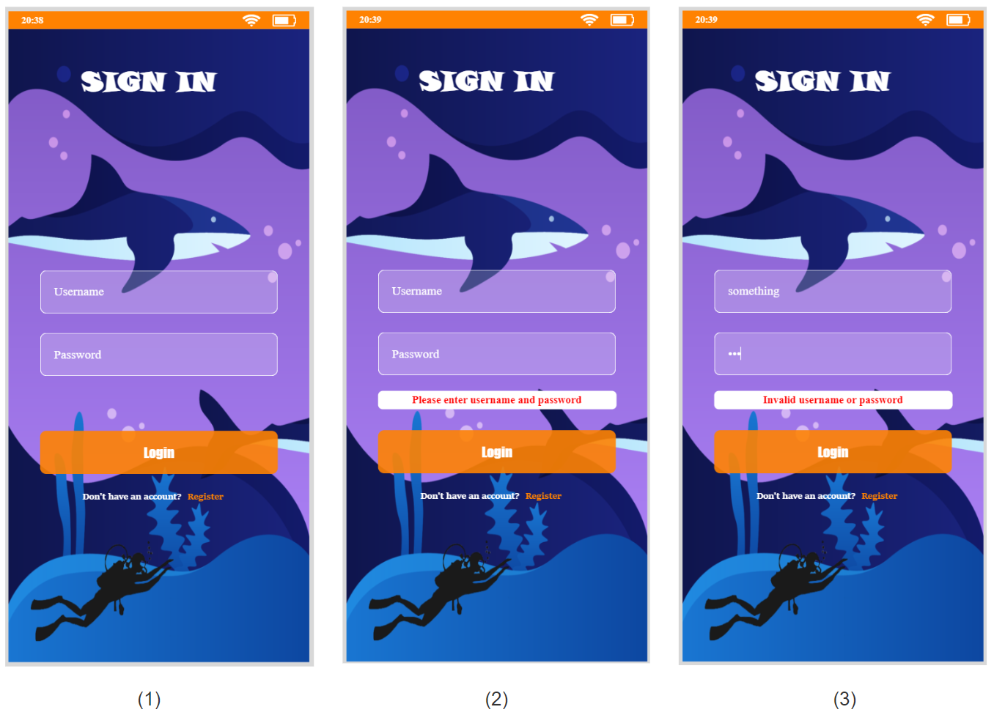

Figure 12 Login screen

Users register an account and log in via the login screen. If there's an error, the system displays a message indicating the mistake.

* **Sign up**

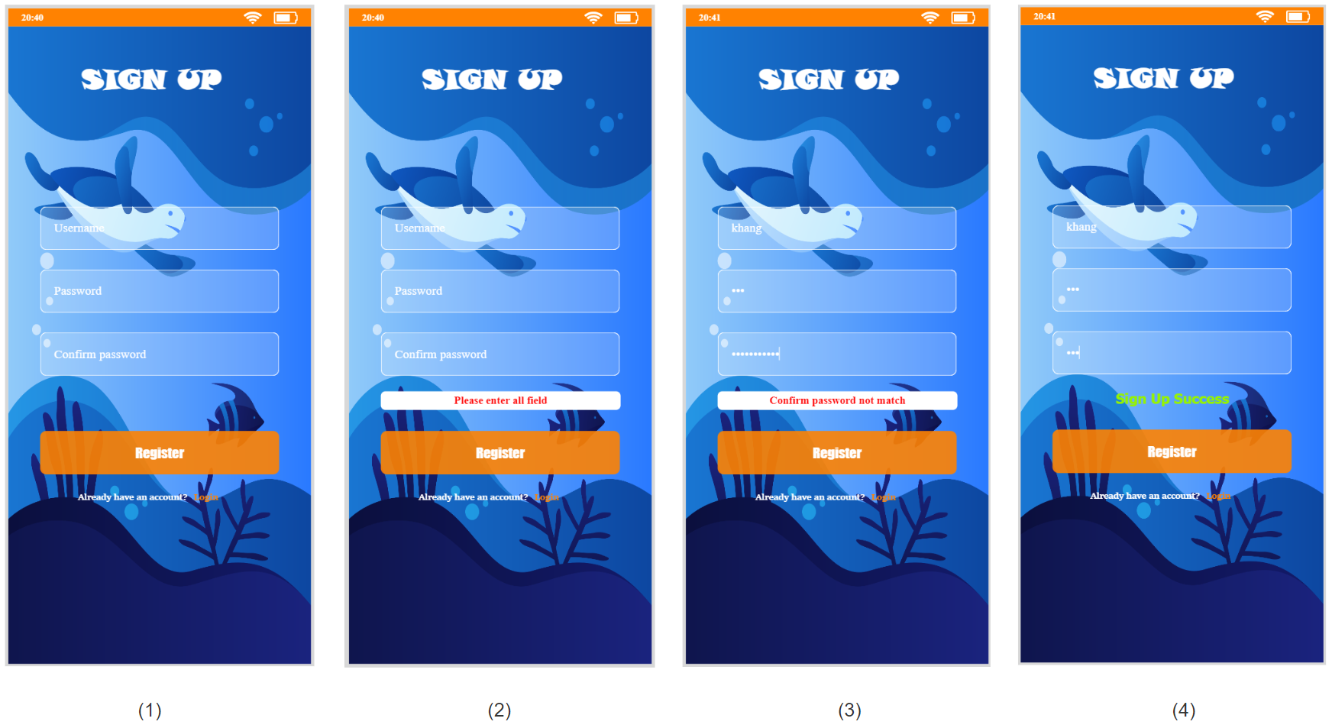

Figure 13 Sign up screen

When the user registers an account at the registration screen, the system will notify them of an error when they enter the wrong input. If registration is successful, the system will display the message "Sign Up Success"

* **Store**

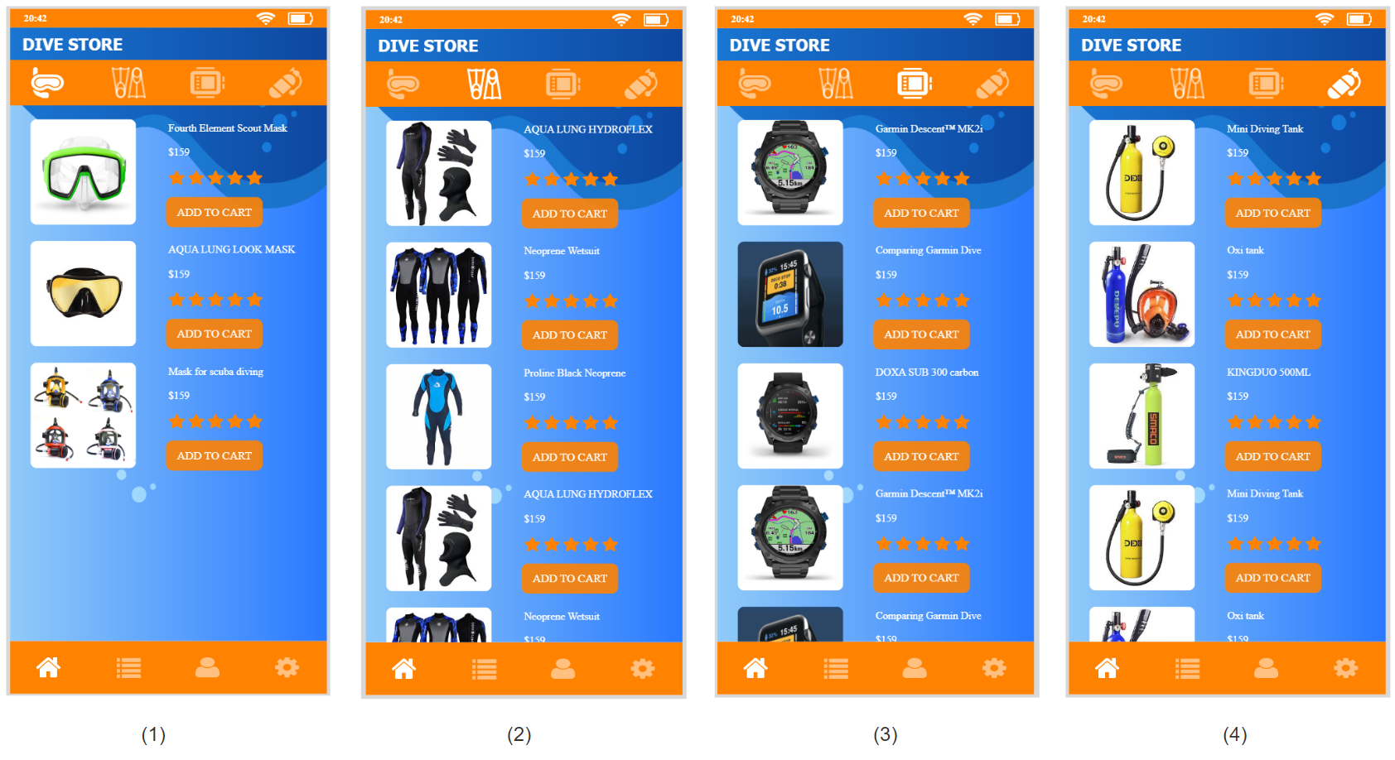

Figure 14 Dive store screen

After a successful login, the system presents the "DIVE STORE" screen, showcasing diving necessities, including four accessory types.

* **Dive log**

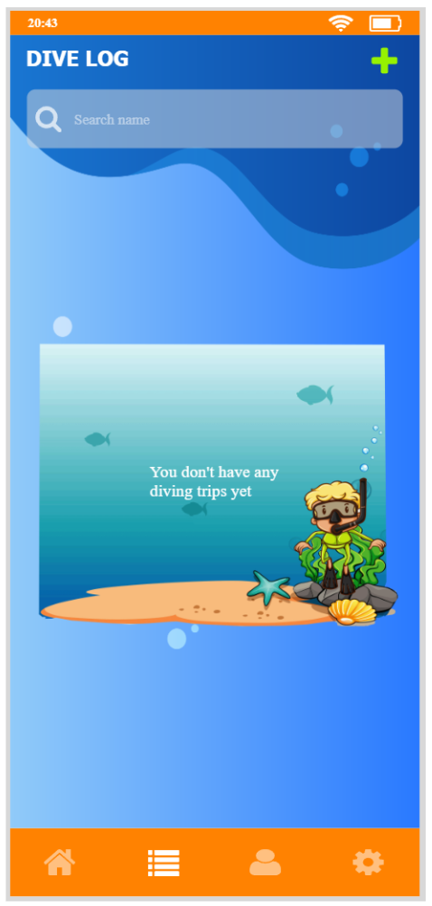

Figure 15 Dive log screen

After a successful login, the system presents the "DIVE STORE" screen, showcasing diving necessities, including four accessory types. Users can switch between accessory categories by clicking each icon on the top navigation bar.

* **Add new dive**

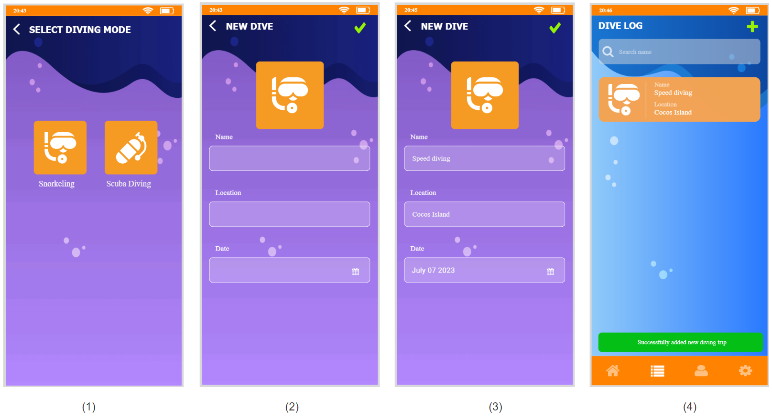

Figure 16 Select diving mode screen (1), Add new dive screen (2,3), Dive log screen (4)

This screen offers diving mode selection, featuring "snorkeling" and "scuba diving" options. Upon selection, the system switches to the dive plan input screen, displaying a corresponding dive thumbnail plan. After successfully adding a dive plan, the system returns to the "DIVE LOG" screen with a success message displayed.

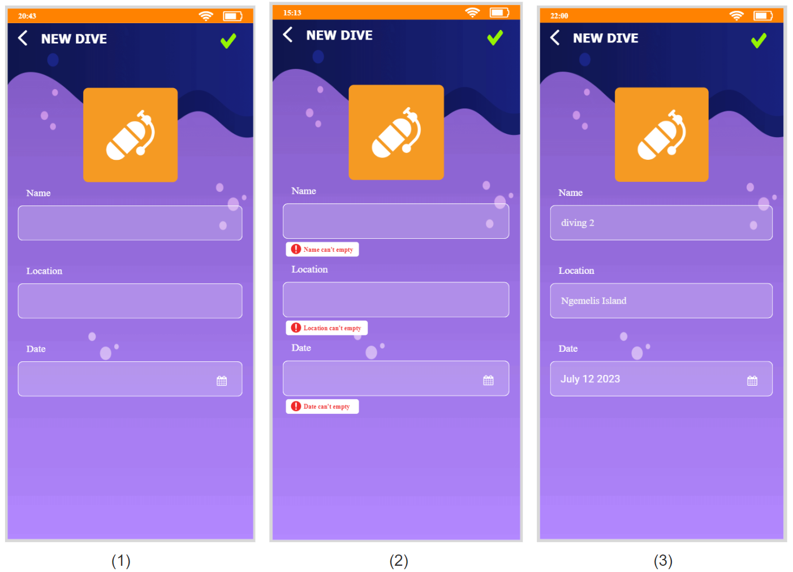

Figure 17 Add another dive mode

The system will also report an error if the user does not enter the required fields.

* **Detail and edit dive**

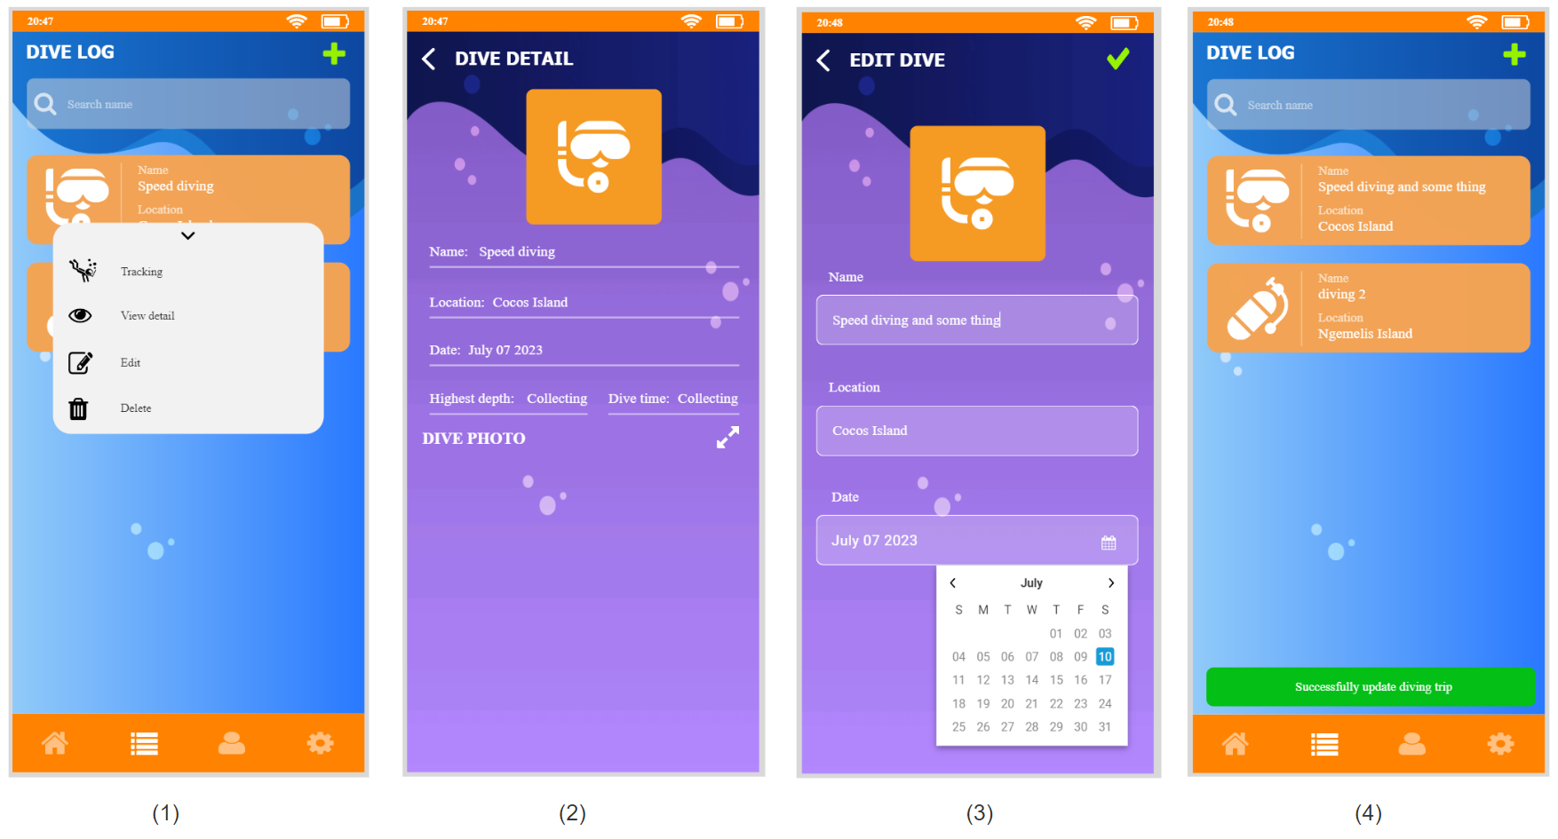

Figure 18 Dive detail screen (2) and edit dive screen (3)

To perform some action with a created dive plan, users need to click on the line they want to operate, then a context menu will be displayed. Next,  click on "Edit" to update or "View Details" to view dive plan details.

* **Tracking**

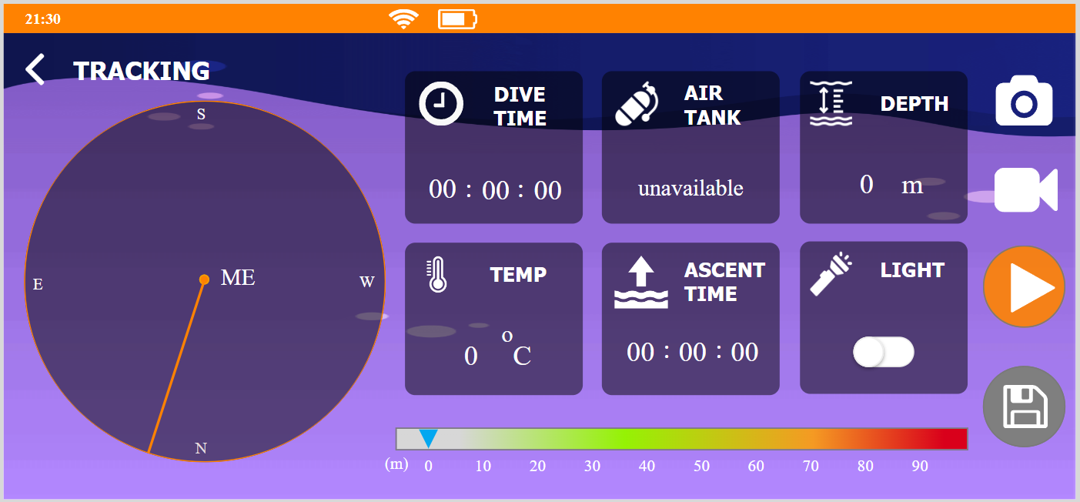

Figure 19 Tracking without air tank screen

Select "Tracking" from the context menu to activate tracking mode. The app will horizontally rotate the screen for a wider view. It will display diving details such as depth, air tank, temperature, ascent time, and dive duration. Moreover, an additional radar feature informs users about moving objects nearby.

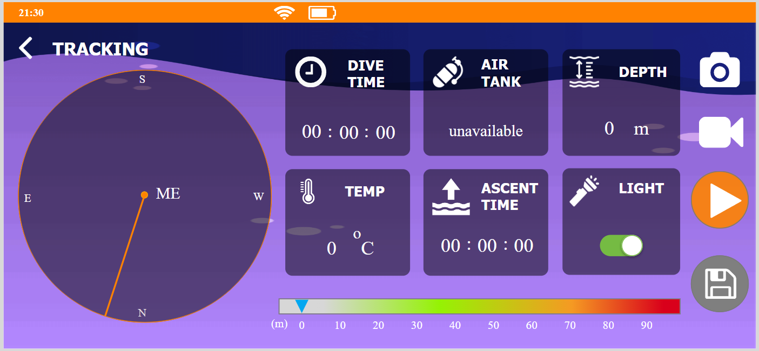

Figure 20 Turn on flashlight

The application provides shortcuts to turn the flashlight on and off.

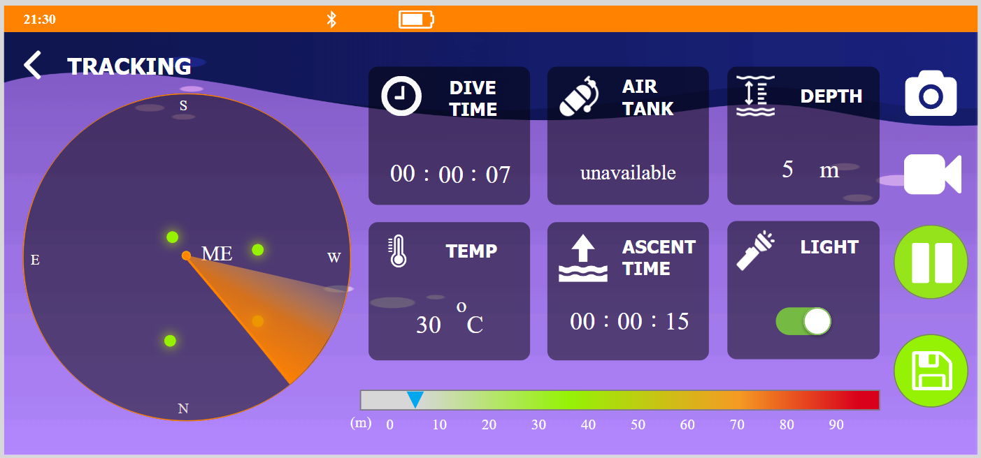

Figure 21 Start tracking

Click on the play icon to start the tracking process.

* **Take photo**

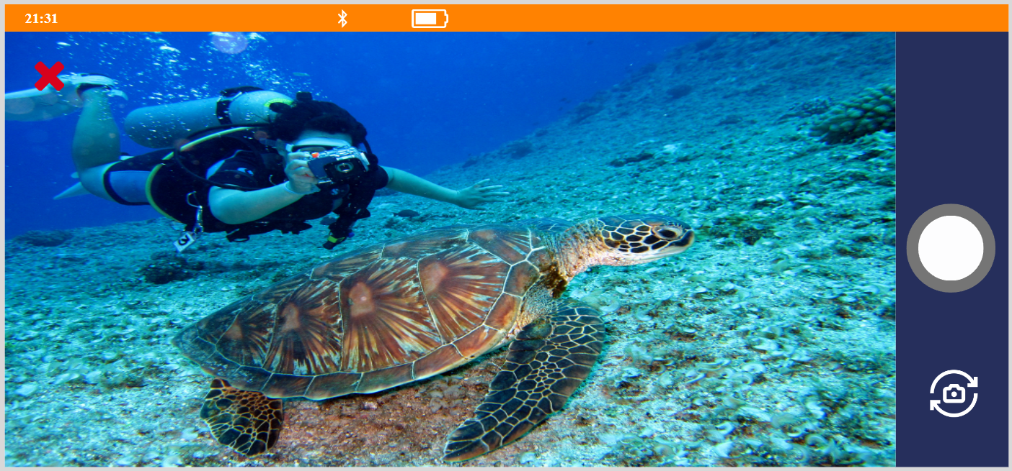

Figure 22 Camera screen

Click on the camera icon to open the camera and take a photo.

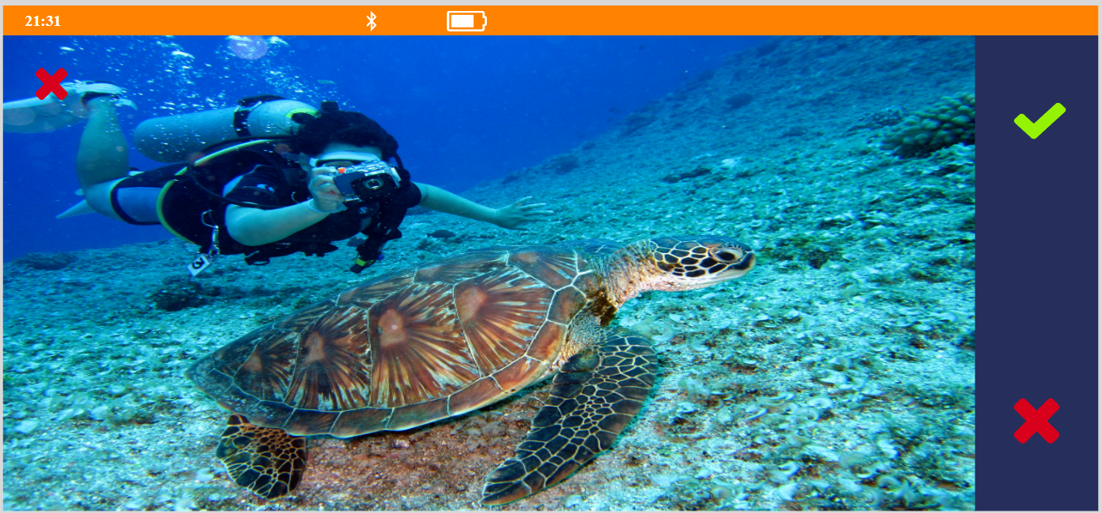

Figure 23 Take a photo screen

Review photos before saving, or cancel and take a new photo.

* **Record video**

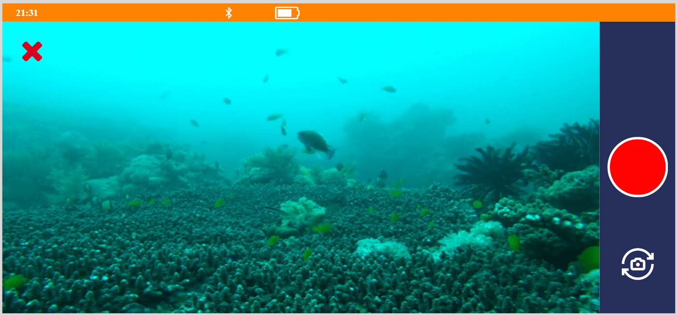

Figure 24 Video screen

Click on the video icon to open the video and record video.

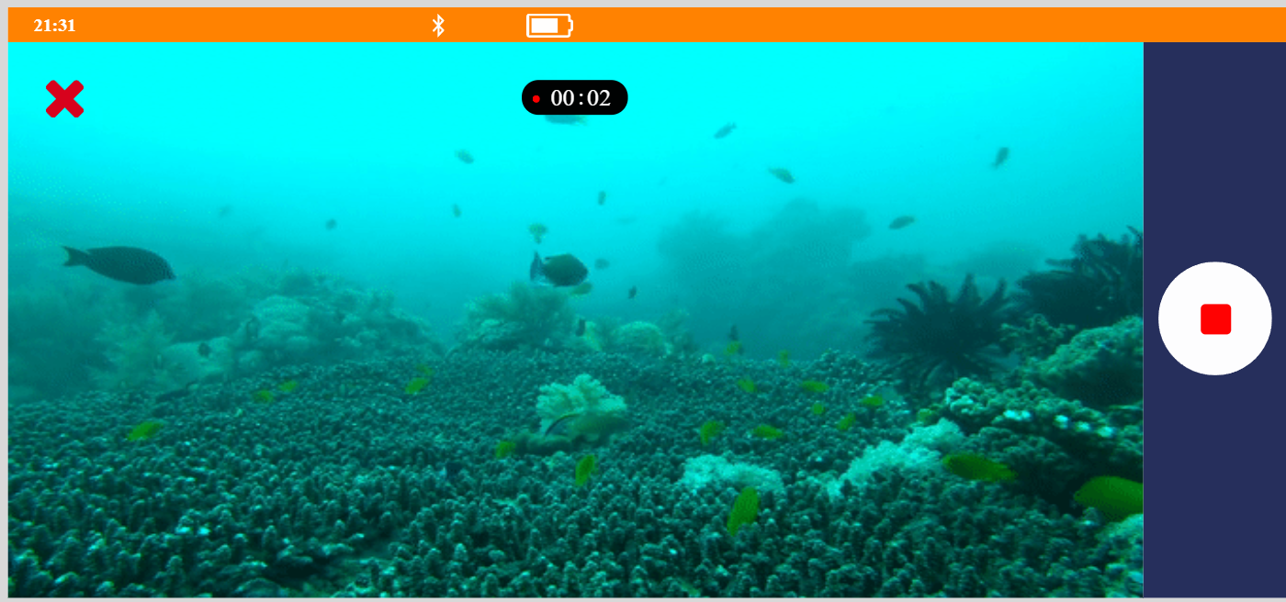

Figure 25 Record video screen

* **Save tracking information**

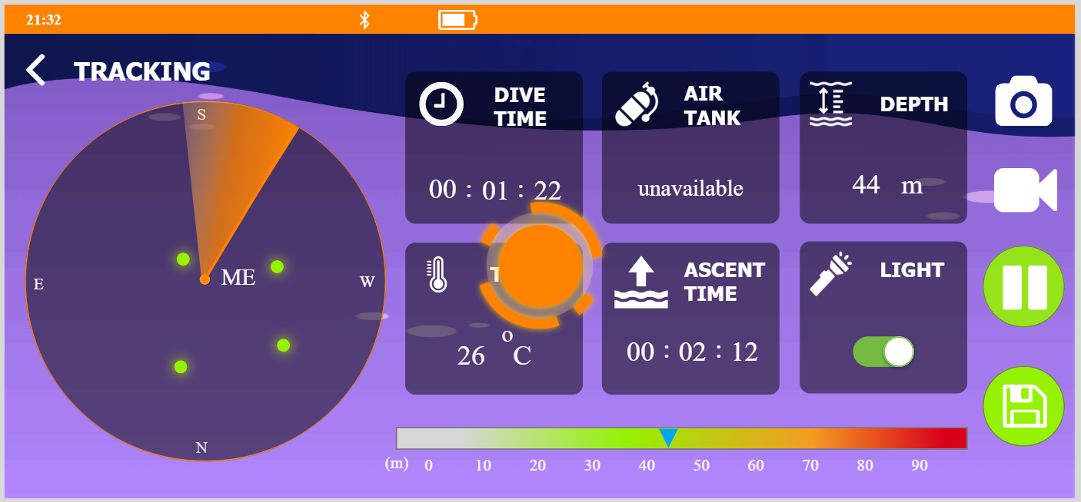

Figure 26 Save information of tracking

Click on save icon to save tracking information

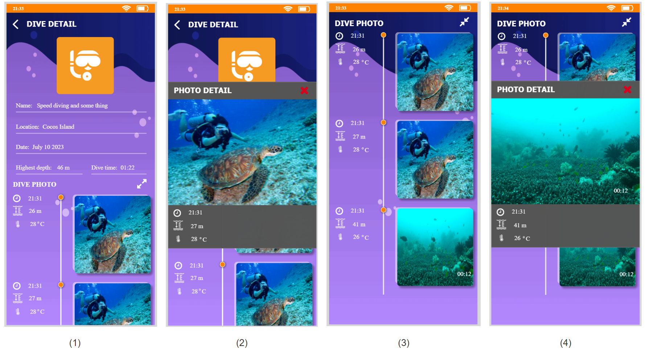

Figure 27 View dive detail after diving screen (1,2) and view expand dive photo screen (3,4)

Tracking information and captured photos will be displayed at the "DIVE DETAIL" screen. Can click on the expand icon to make the list full-screen. Users can click on the image to open it larger.

* **Scuba diving**

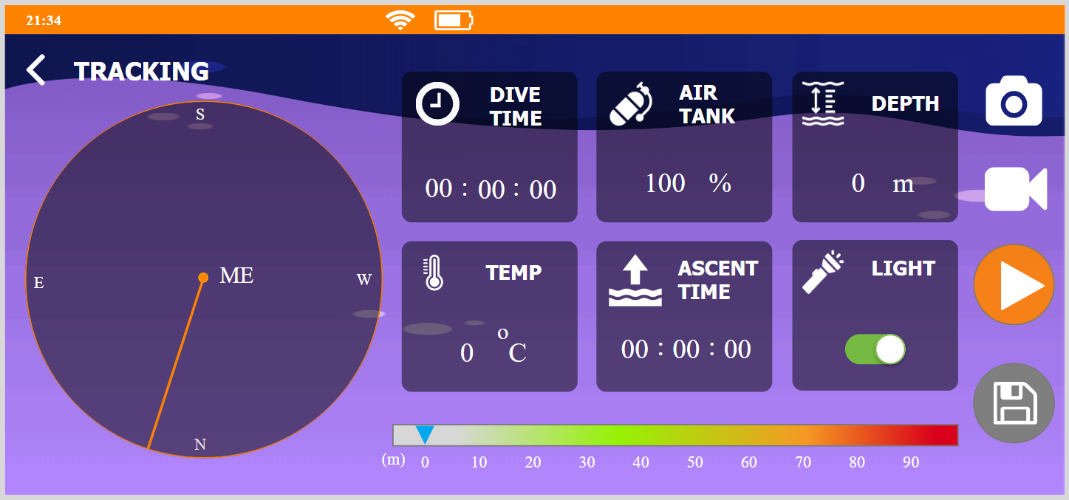

Figure 28 Tracking with air tank screen

When tracking "scuba diving," information on "air tank" will be available.

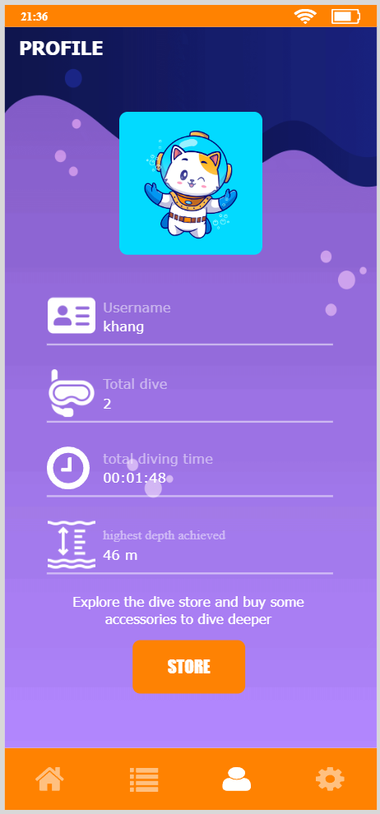

Figure 29 Profile screen

This is the profile screen. Here is information such as total dives, total dive time, and the highest depth reached.

* **Settings**

On the settings screen, users can perform a number of functions, such as turning WiFi and Bluetooth on and off, viewing help, and reviewing the application's terms and policies. Additionally, users can logout.

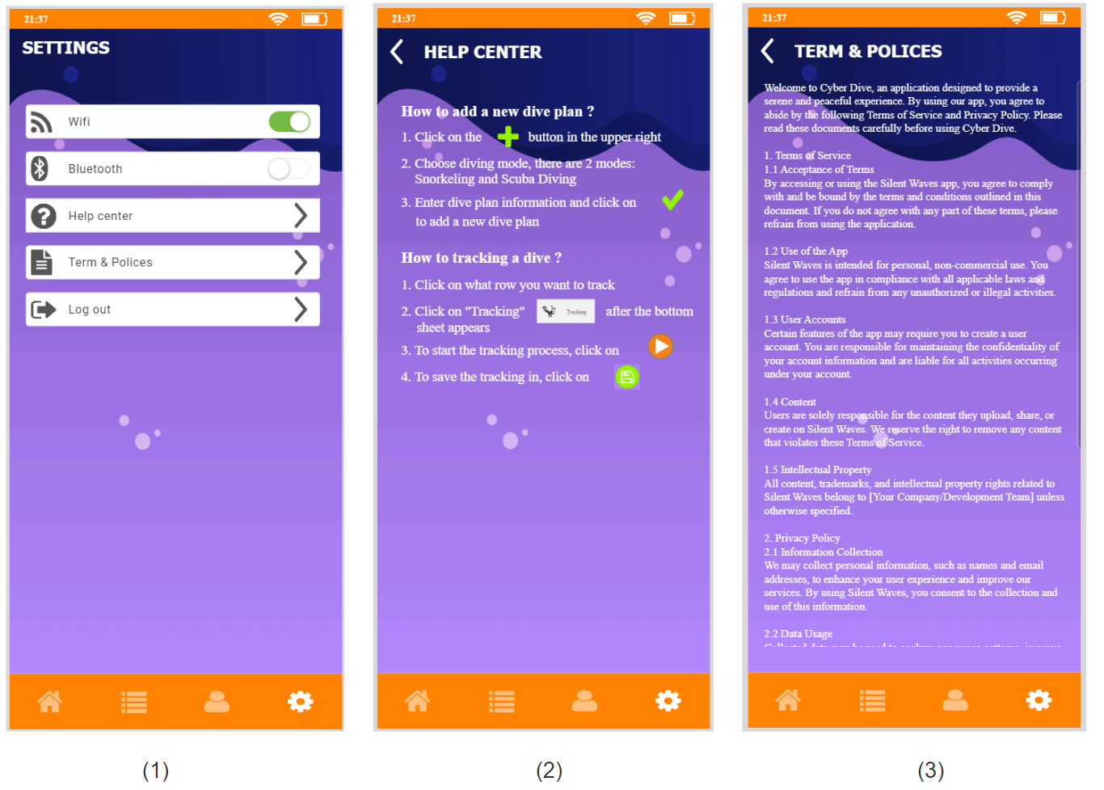

Figure 30 Setting screen (1), Help center screen (2) and Term & polices screen (3)

1. **Research Study**

**Hypotheses:**

* Hypotheses 1:The application's features can meet the basic needs of users.
* Hypotheses 2:The application is beautifully designed, simple, and easy to use.

**Research methods:** quantitative and qualitative.

**Context:** Survey.

**Participants:**

* Quantity: 15 participants from diving clubs
* Age groups: 18-30
* Genders: both men and women
* Jobs: professional and recreational divers.

**Study Execution:** surveys distributed online.

**Data Analysis:** use google form to statistical for survey data.

Below are the results of a survey of 15 divers:

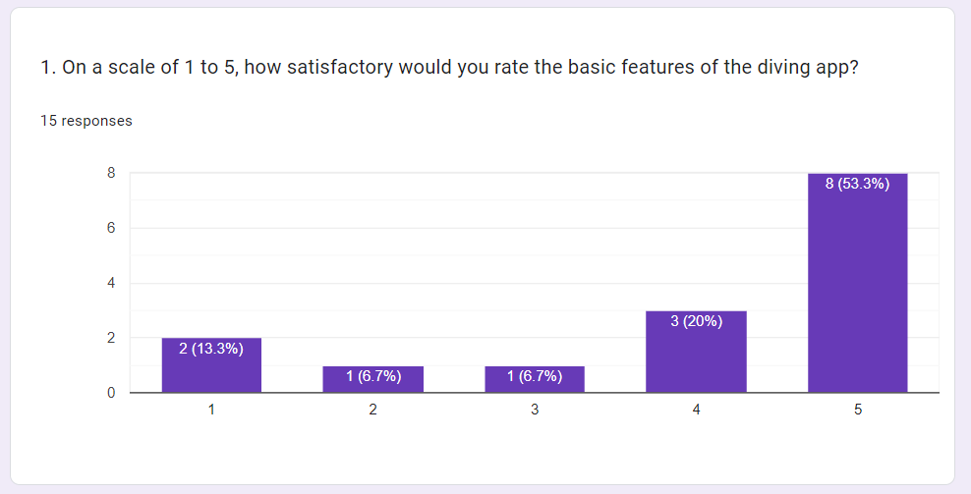

Figure 31: Result of question 1

73.3% of users rated the app's basic features as good (4 points) or very good (5 points), indicating high satisfaction. However, 26.7% rated it lower (1, 2, or 3 points), suggesting dissatisfaction among a minority of users with these features.

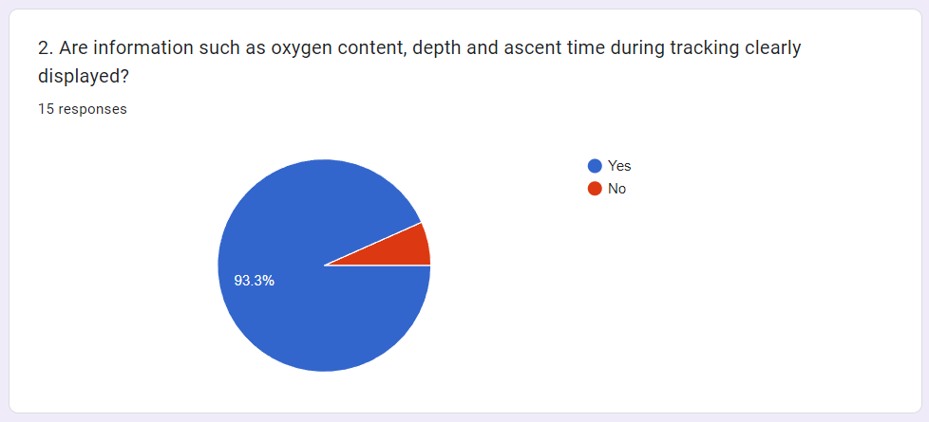

Figure 32 Result of question 2

93.3% of respondents find information like oxygen content, depth, and ascent time clearly displayed during tracking, while 6.7% disagreed, stating that this information is not clear.

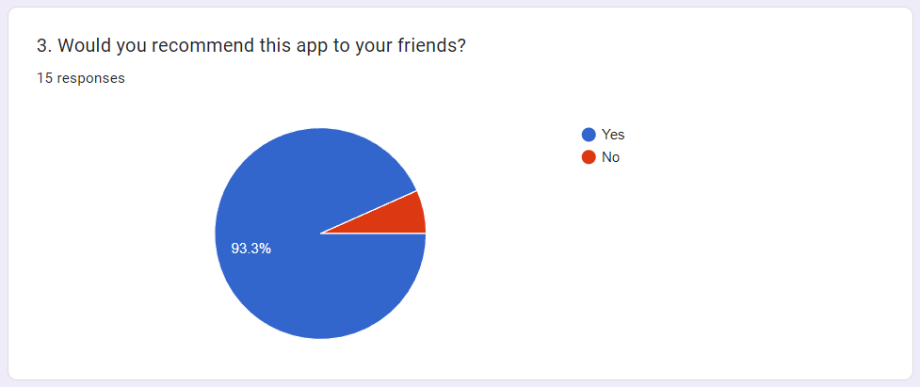

Figure 33 Result of question 3

93.3% of respondents are likely to recommend the app to their friends, while 6.7% stated they would not recommend it.

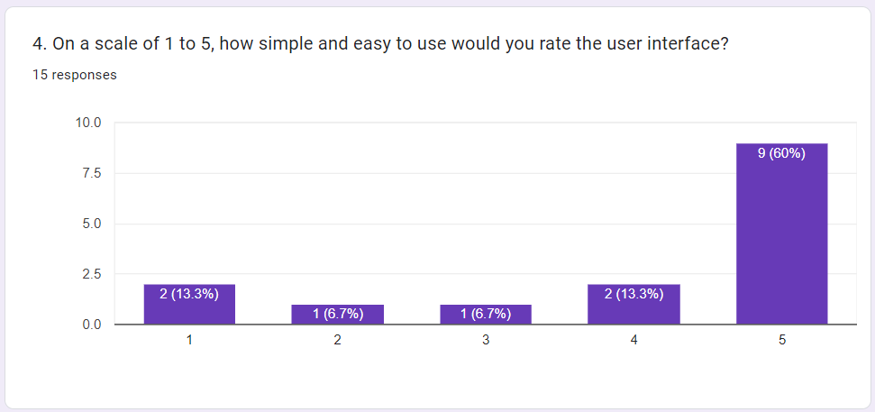

Figure 34 Result of question 4

60% of users rated the user interface with the highest score (5 points), finding it extremely simple. However, 13.3% rated it lower (1 or 4 points), suggesting some found it challenging or not as straightforward, but a larger portion still found it relatively good.

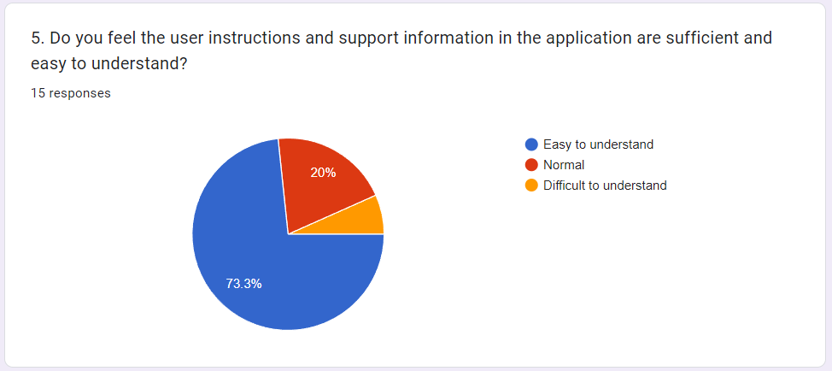

Figure 35 Result of question 5

73.3% of users find the app's instructions and support "Easy to understand," while 20% consider them "Normal." Yet, 6.7% find these resources "Difficult to understand," indicating challenges for some in grasping the provided guidance.

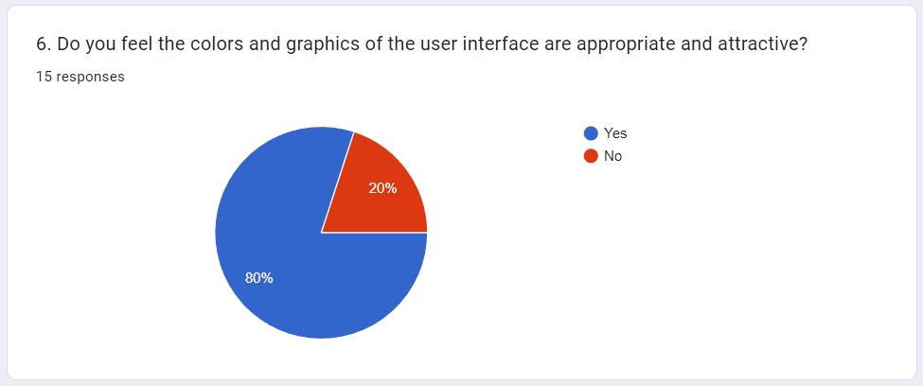

Figure 36 Result of question 6

80% approve of the user interface's colors and graphics, signaling a largely positive perception. However, 20% find them unappealing, indicating a minority dissatisfaction with the visual elements.

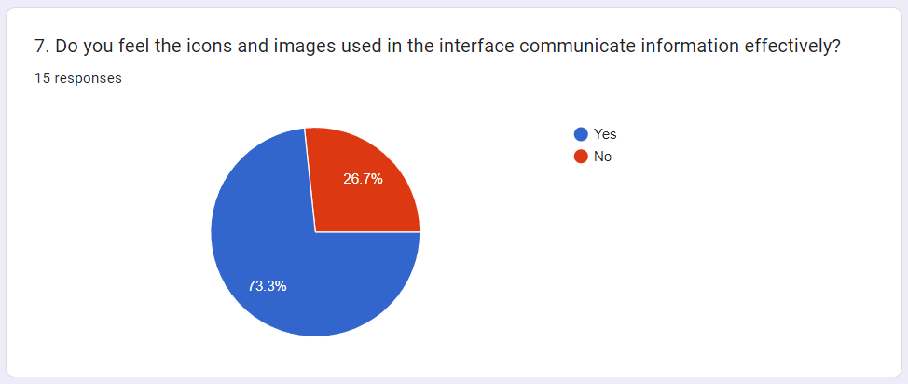

Figure 37 Result of question 7

73.3% of respondents find the icons and images in the interface effective in communicating information. However, 26.7% do not, indicating a minority facing difficulties in understanding the conveyed information through these visual elements.

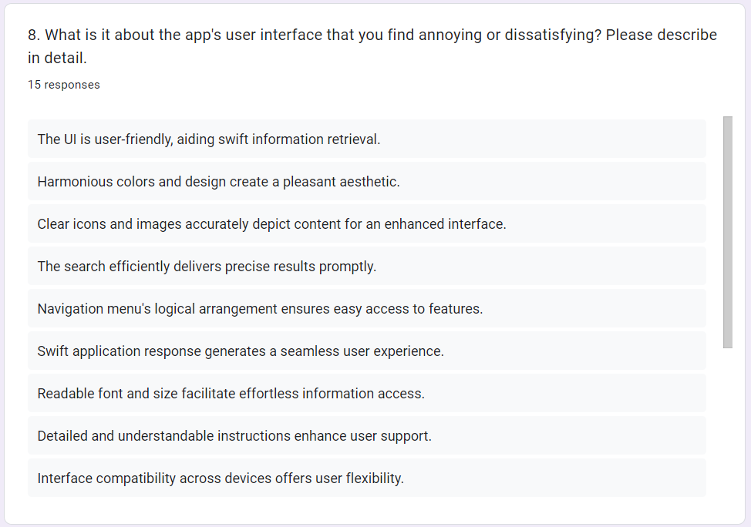

Figure 38 Result of question 8

Positive feedback emphasizes the app's user-friendly interface, appealing design, clear elements, efficient functionality, and good support. Yet, concerns exist regarding color strain, unclear instructions for new users, and information organization issues, impacting user experience negatively.

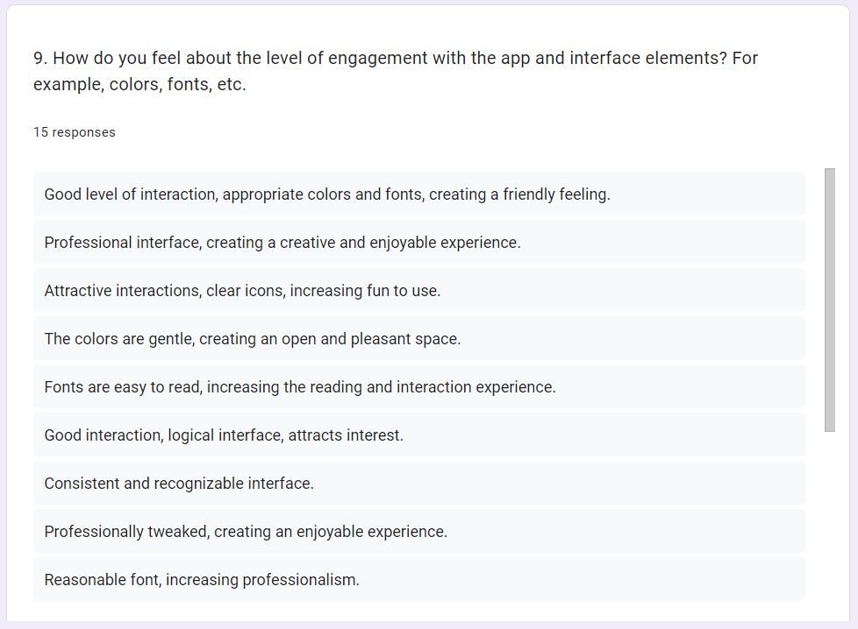

Figure 39 Result of question 9

Positive feedback highlights the app's use of suitable colors, readable fonts, appealing interactions, and a consistent, professional design that enhances user engagement. However, negative feedback cites issues with mismatched colors and fonts, detracting from the attraction and interaction experience.

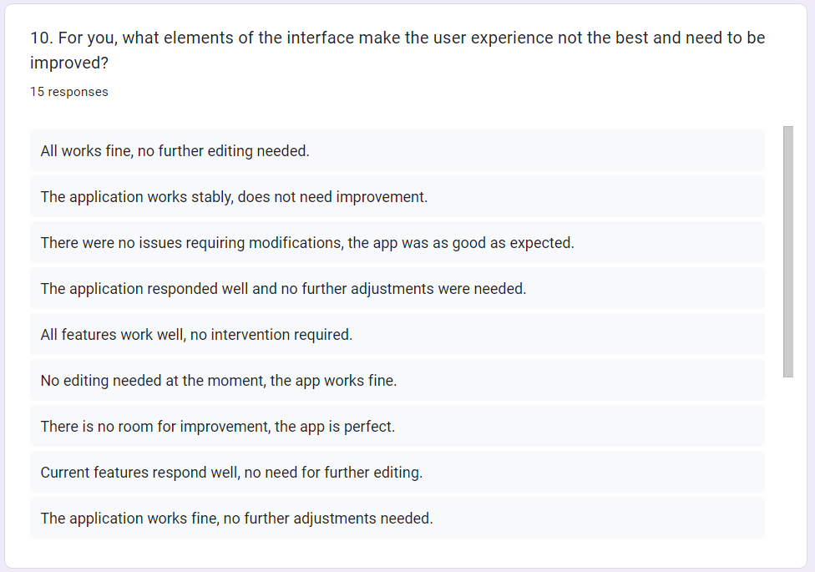

Figure 40 Result of question 10

Positive feedback generally shows satisfaction with the app's performance, suggesting no need for further changes. However, negative feedback points out delays in operations, complexities in organizing information, and compatibility issues on some devices or browsers that require improvement for enhancing user experience.

Based on the survey results my initial two theories were correct. However, there are still some negative comments. I will take those into consideration and improve my interface.

Table 3 Nielsen usability heuristics

|  |  |  |
| --- | --- | --- |
| **Heuristics** | **Design** | **Description** |
| Visibility of system status |  | The system will be display loading animation when user save tracking.  My application's tracking interface, I'll use larger fonts and high-contrast colors for better visibility in low-light or low-visibility conditions. |
| Match between the system and the real world |  | Using icons that resemble real objects helps users easily recognize them. |
| User control and freedom |  | When user delete data, a confirm popup will be display to user confirm action. |
| Consistency and standards |  | Always use check icon for saving something in the application. |
| Error prevention |  | When the input is invalid, the system will display an error message. |
| Recognition rather than recall |  | Use common icons. |
| Flexibility and efficiency of use |  | Quickly switch between camera and video recording. |
| Aesthetic and minimalist design |  | The interface and icons are simple, not detailed, only displaying necessary information. |
| Help users recognize, diagnose, and recover from errors |  | Inform users where they went wrong. |
| Help and documentation |  | Instructions for the use of functions.  term and policies in my application. |

1. **Conclusion**

This research study comprehensively navigated through the intricacies of UI/UX design, leveraging HCI theories, design principles, and a meticulous design process. It paves the way for an enhanced ocean diving application that not only meets user needs but also ensures an intuitive and engaging experience for divers.

# References

aqualung, 2023. *aqualung.* [Online]   
Available at: https://aqualung.com.au/products/i770r-dive-computer  
[Accessed 18 11 2023].

diveboard, 2023. *diveboard.* [Online]   
Available at: https://www.diveboard.com/  
[Accessed 18 11 2023].

GÁBOR, F., 2021. *figma.* [Online]   
Available at: https://www.figma.com/file/KSOoz2P8qv1jjztYq3pyDK/Diving-App-Concept-(Community)?type=design&node-id=6-44&mode=design  
[Accessed 18 11 2023].

garmin, 2023. *garmin.* [Online]   
Available at: https://www.garmin.com/en-US/p/632320  
[Accessed 18 11 2023].

Jeff Johnson, A. H., 2011. *Conceptual Models - Core to Good Design.* s.l.:Morgan & Claypool.

Knoch, S., 2023. *Google play.* [Online]   
Available at: https://play.google.com/store/apps/details?id=com.divinglog.divelog&hl=en_US  
[Accessed 18 11 2023].

libguides, 2023. *libguides.* [Online]   
Available at: https://libguides.uta.edu/quantitative_and_qualitative_research/qual  
[Accessed 24 11 2023].

libguides, 2023. *libguides.* [Online]   
Available at: https://libguides.uta.edu/quantitative_and_qualitative_research/quant  
[Accessed 24 11 2023].

Rogers, Preece and Sharp, 2015. *Interaction Design: Beyond Human-computer Interaction.* s.l.:Wiley.

Rogers, P. a. S., 2019. *Interaction Design: Beyond Human-computer Interaction.* s.l.:Wiley.

ui-patterns, 2023. *ui-patterns.* [Online]   
Available at: https://ui-patterns.com/patterns/AccountRegistration  
[Accessed 24 11 2023].

ui-patterns, 2023. *ui-patterns.* [Online]   
Available at: https://ui-patterns.com/patterns/settings  
[Accessed 24 11 2023].

ui-patterns, 2023. *ui-patterns.* [Online]   
Available at: https://ui-patterns.com/patterns/InputPrompt  
[Accessed 24 11 2023].

# Appendices

Link of google form:

<https://docs.google.com/forms/d/e/1FAIpQLScyneJtgUI8OWOS0vzI1dkAv5KXLU-pwMiIdLvbjt83K8tAUg/viewform>

